Year 7 Science

Water Treatment Investigation

**Outcomes:** Science Inquiry; Science Understanding: Earth and Space

**Aim:** To test the effectiveness of different types materials as filters

This investigation will involve using different materials for filtering water. The materials we are going to use are kitchen towel, kitchen chux and sponge

**Can you write this as a question to be investigated?**

________________________________________________________________________________________________________________________________________________________________________________________________________________________________________________________

**Hypothesis:**

____________________________________________________________________________________________________________________________

**Apparatus:** Draw a labelled diagram (or series of diagrams) to show how you filtered the polluted water. **Results:**

Write a title for your table.

Write units for headings that need them.

Record your results in the table below.

Title:__________________________________________________________

|  |  |  |  |  |
| --- | --- | --- | --- | --- |
| Filtering Material | Weight before  (grams) | Weight after  (grams) | Weight change  (grams) | Appearance of filtrate |
| Tea towel |  |  |  |  |
| Kitchen chux |  |  |  |  |
| sponge |  |  |  |  |

**Discussion:**

What was your independent (changed) variable?

______________________________________________________________

What was your dependent (measured result) variable?

______________________________________________________________

What were three controlled (kept the same) variables?

__________________________________________________________________________________________________________________________________________________________________________________________

Discussion: Was there a pattern in your results?

______________________________________________________________________________________________________________________________________________________________________________________________________________________________________________________________________________________________________________________

______________________________________________________________

Did you have any difficulties or problems with your experiment? (With your method)

________________________________________________________________________________________________________________________________________________________________________________________________________________________________________________________

How would you fix this problem if you did this experiment again?

______________________________________________________________________________________________________________________________________________________________________________________________________________________________________________________________________________________________________________________

**Conclusion:**

What was the overall result?

____________________________________________________________________________________________________________________________

__________________________________________________________________________________________________________________________________________________________________________________________

Was your prediction correct? Explain

______________________________________________________________________________________________________________________________________________________________________________________________________________________________________________________________________________________________________________________

Draw a graph:

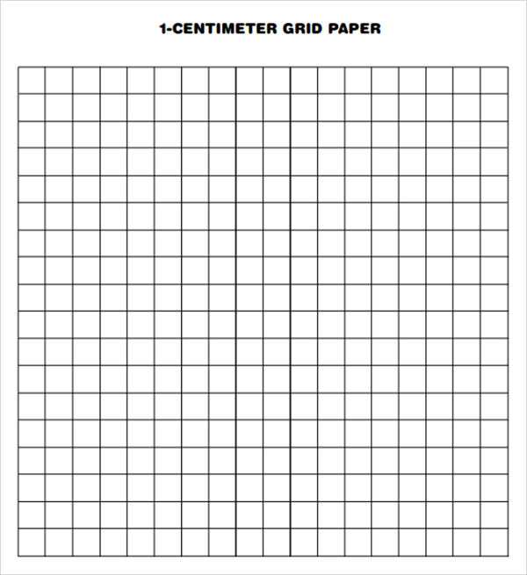

|  |  |  |  |
| --- | --- | --- | --- |
|  |  | Mark Allocation | Mark |
| Questions | * Writes a question which refers to independent and dependent variables | 1 |  |
| Prediction | * Writes a prediction as a sentence | 1 |  |
| Diagram(s) | * Diagram(s) shows all equipment, including sizes or types * Diagram(s) indicate method for weight measurement * Diagram is neat, in pencil, suitable size and stylised and two dimensional | 3 |  |
| Results | * Table title relates independent and dependent variables * Calculations include units where appropriate * Describes the appearance of filtrate | 3 |  |
| Graph | * Graph title relates variables * Graph type is appropriate * Axis are correct, labelled * Graph is appropriate size and scale | 4 |  |
| Variables | * Independent variable is identified * Dependant variable is identified * 1-3 controlled variables identified | 3 |  |
| Discussion | * Mentions about appearance and filtrate * Difficulties or sources of error identified * Suggestion for improvement | 3 |  |
| Conclusion | * Summary of findings * Prediction correct or not | 2 |  |
|  |  | Total  /20 |  |